* : Summary of whole work :-

**Purpose:**

Main purpose of this experiment is to make a low cost spectrophotometer. Because the cost of a laboratory scale spectrophotometer is high, and thus it is not feasible to use it for the routine experiments. Even in high schools and colleges, the spectrophotometer is not made available for use on daily basis. Owing to its wide range of applications, it can be put to extensive use if made available at low cost. The sensitivity and efficiency might be compromised to some extent in this process of cost reduction, but it shall be possible to perform basic experiments with the accuracy which is equivalent to a high-end spectrophotometer [7].

In addition to its application in schools and research, it can be made available in laboratories to conduct experiments in which it performs accurately. A few such examples include blood tests in which density and colour of blood changes after some kind of pre-processing. Another area where the results can be comparable to actual spectrophotometer include tests on different proteins. Owing to a low-cost this instrument can be used to perform tests which might actually require very sophisticated instruments in industries.

**Features/Object:**

It is known that every chemical compound or substance transmits, reflects or absorbs a certain range of wavelength in electromagnetic spectrum and this transmittance or absorbance by a particular compound is measured is the study of spectrophotometry. It is employed largely for quantitative analysis in various domains such as chemistry, biology, biochemistry, physics, chemical and material engineering, applications at clinical or industrial level, etc. An application that involves the chemical compounds or materials can use this technique. For example, in the field of biochemistry, it is applied for determining enzyme-catalysed reactions by studying the absorbance over a period of time at certain intervals. In case of clinical applications, it is employed for examining blood or tissues for the purpose of diagnosis. Also, there are many variations among spectrophotometry. Some examples are atomic absorption spectrophotometry or atomic emission spectrophotometry .

A spectrophotometer can be defined as an instrument that measures the rate of photons absorbed after the light passes through the sample solution. The number of photons is determined by measuring the intensity of light. Using this, the concentration of a known chemical compound can also be estimated. Depending on the range of wavelength of light source, it can be classified into two different types:

UV-visible spectrophotometer: It uses light over the range 185 - 400 nm, that is ultraviolet range, and 400 - 700 nm, that is visible range, of the electromagnetic radiation spectrum.

IR spectrophotometer: uses light over the range of range 700 - 15000 nm, that is Infrared, of the electromagnetic radiation spectrum. 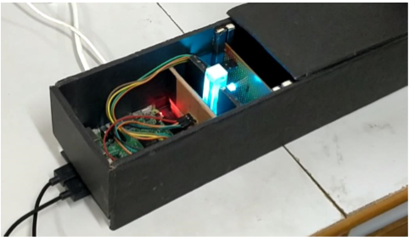

**1.6 APPLICATIONS OF SPECTROPHOTOMETER:**

• Determination of concentration of an unknown solution.

• Detection of organic compounds by analysing the maxima of absorption values.

• Determination of Color of the unknown compund based on the spectral range observed.

• Detection of impurities (UV absorption spectroscopy is one of the best methods for determination of impurities in organic molecules).

• Chemical Kinetics (The absorption changes are detected when the UV radiations are passed through reaction cells).

• Molecular weight determination.

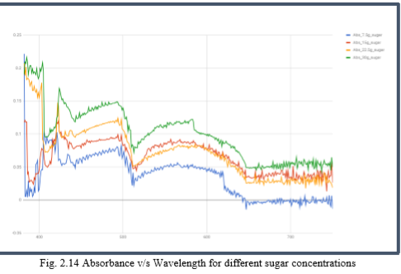

* **What I did…….**

1. **Tested many dyes and different solution at biotech lab.**

-green dyes.

- blue dyes.

- brown dyes.

-impure water.

- protein solution.

**2.)Found the root of problem due to which there is deviation in our curve.**

:- Their was some issue in formula created for blinking of led at certain wavelength .

*#old Function to convert the wavelength into RGB values***def** (wavelength):  
 *# Gamma Correction Limit* gamma = 0.8  
  
 w = float(wavelength)  
  
 *# colour* **if** w >= 380 **and** w <= 440:  
 attenuation = 0.3 + 0.7 * (w - 380) / (440 - 380)  
 R = ((-(w - 440) / (440 - 380)) * attenuation) ** gamma  
 G = 0.0  
 B = (1.0 * attenuation) ** gamma  
 **elif** w >= 440 **and** w <= 490:  
 R = 0.0  
 G = ((w - 440) / (490 - 440)) ** gamma  
 B = 1.0  
 **elif** w >= 490 **and** w <= 510:  
 R = 0.0  
 G = 1.0  
 B = (-(w - 510) / (510 - 490)) ** gamma  
 **elif** w >= 510 **and** w <= 580:  
 R = ((w - 510) / (580 - 510)) ** gamma  
 G = 1.0  
 B = 0.0  
 **elif** w >= 580 **and** w <= 645:  
 R = 1.0  
 G = (-(w - 645) / (645 - 580)) ** gamma  
 B = 0.0  
 **elif** w >= 645 **and** w <= 750:  
 attenuation = 0.3 + 0.7 * (750 - w) / (750 - 645)  
 R = (1.0 * attenuation) ** gamma  
 G = 0.0  
 B = 0.  
 **else**:  
 R = 0.0  
 G = 0.0  
 B = 0.0  
 R *= 255  
 G *= 255  
 B *= 255  
 R = int(R)  
 G = int(G)  
 B = int(B)  
  
 **return** [R, B, G]

*#Corrected formulae……:-*

void spectral_color(double &r,double &g,double &b,double l) // RGB <0,1> <- lambda l <400,700> [nm]

{

double t; r=0.0; g=0.0; b=0.0;

if ((l>=400.0)&&(l<410.0)) { t=(l-400.0)/(410.0-400.0); r= +(0.33*t)-(0.20*t*t); }

else if ((l>=410.0)&&(l<475.0)) { t=(l-410.0)/(475.0-410.0); r=0.14 -(0.13*t*t); }

else if ((l>=545.0)&&(l<595.0)) { t=(l-545.0)/(595.0-545.0); r= +(1.98*t)-( t*t); }

else if ((l>=595.0)&&(l<650.0)) { t=(l-595.0)/(650.0-595.0); r=0.98+(0.06*t)-(0.40*t*t); }

else if ((l>=650.0)&&(l<700.0)) { t=(l-650.0)/(700.0-650.0); r=0.65-(0.84*t)+(0.20*t*t); }

if ((l>=415.0)&&(l<475.0)) { t=(l-415.0)/(475.0-415.0); g= +(0.80*t*t); }

else if ((l>=475.0)&&(l<590.0)) { t=(l-475.0)/(590.0-475.0); g=0.8 +(0.76*t)-(0.80*t*t); }

else if ((l>=585.0)&&(l<639.0)) { t=(l-585.0)/(639.0-585.0); g=0.84-(0.84*t) ; }

if ((l>=400.0)&&(l<475.0)) { t=(l-400.0)/(475.0-400.0); b= +(2.20*t)-(1.50*t*t); }

else if ((l>=475.0)&&(l<560.0)) { t=(l-475.0)/(560.0-475.0); b=0.7 -( t)+(0.30*t*t); }

}

**3.) Observed different light source and tested against different condition.**

Deviation in graph was due to change in temperature and due to the scattering of light travelling towards sensor. So I suggested some component regarding this issue and makes component list and send them to dic.

**4.) Little bit changes in program …**

:- Observing two or three time the same solution at the same time by increasing the frequency of raspberry pi and taking the average of all reading which makes the graph more accurate and near to correct result.

**5.) Requested for thormoco**l **which makes the device isothermal .**

:- Every black body radiates some energy according to their temperature, hence there is deviation in reading of same solution at different places because our reading is all about the measure of intensity of light coming from source….